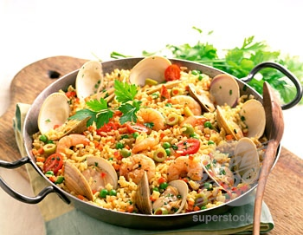**Homework # 6**

We are learning about food in Spanish class, so this video is going to teach you some food people in Spain eat. You will be able to find the difference between American food and food in Europe, particularly in Spain.

Please watch this video <https://www.youtube.com/watch?v=cz0xCBPmi8c> and answer the questions below in **English.** The words in the **word bank** are the vocabulary used on the video. After you watch the video you may need to look for their meaning online.

camarero croquetas la cuenta Tapas paella paella de pollo paella de mariscos paella de chorizo café con leche churros jamón serrano

Tortilla Española

1. **What are the American food places the girl in the video finds in Spain?** ¿Que lugares de comida Americana encuentra la chica del video?

______________________________________________________________________________

1. **Who did she ask about what foods to get?** ¿A quien pregunta ella acerca de que comida pedir?

______________________________________________________________________________

1. **What are the three most popular dishes in Spain?** ¿Cuáles son los platos mas populares en España?

______________________________________________________________________________

1. **What was the girl on the video’s favorite “croquetas”?** ¿Cuales fueron las croquetas favoritas para la chica del video?

______________________________________________________________________________

1. **What type would have been yours? Why?** ¿Que tipo habria sido el tuyo? Porque?

______________________________________________________________________________

1. **How do you say “the bill” in Spanish?** ¿Como se dice “the bill” in Spanish?

______________________________________________________________________________

1. **How many types of “Paella” did you hear about?** ¿Cuántos tipos de Paella viste?

______________________________________________________________________________

1. **How big can paella pans for parties?** ¿Que tan grandes pueden ser las pailas para paella para las fiestas?

______________________________________________________________________________

1. **From the choices for breakfast on the video, which one do you prefer?** De las opciones para el desayuno, cual prefieres?

**______________________________________________________________________________**

1. **Fill in the Venn diagram showing the similarities and differences between “Tortilla Española” and “Tortilla Mexicana” Hint: What they are made of/what they look like.**

Tortilla Mexicana

Tortilla Española

